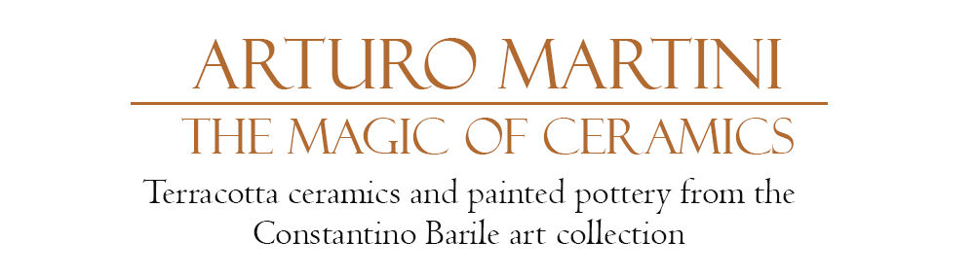
Lo Zio, 1926, terracotta, cm 34x21x16
Contini Art Gallery
Piazza Silvestro Franceschi, 7 - Cortina d’Ampezzo (BL)

29 DECEMBER 2018 – 22 APRIL 2019

This exhibition reveals forty unseen artworks by Arturo Martini (Treviso, 1889-1947) from the prestigious art collection of Constantino Barile (Albisola 1886 – 1968 a studious historian and lawyer) who knew the artist personally. Preceding the likes of Lucio Fontana, Arturo Martini’s sculptural creations present an engagement with the historical traditions from the region of Liguria, and an attempt to renew the Ligurian artistic language. The exhibition offers a rare opportunity to view a myriad of terracotta ceramics by Arturo Martini of excellent provenance, which Constantino Barile displayed in his private home alongside traditional blue pottery from the region of Liguria.
The works displayed in this exhibition depict the artist’s creative imagination during the 1920s, Martini’s large sculptures in plaster are both daring and delicate, executed with great agility showing the marks of a storyteller who tested the limits and possibilities of ceramic making. As a creative narrator, Martini worked outside any rigid system of order, he was an experimental artist stimulated by the tactile and colorful potential of clay, an inventor of the unknown.
During his adolescent years, Martini worked as an artisan in his hometown Treviso, where he learnt technical skills that would later serve him in ceramic making. The young and curious Martini was ardent to discover the art and design outside on exhibit in Paris in the great Art Déco (Decorative Arts) exhibition of 1925.
The works presented in this exhibition are some of the artist’s most influential works, in particular the famous portrait of his daughter Maria entitled La Nena, whom he captured and portrayed during the moment she left home. Another poignant work on display is the portrait of his uncle entitled Zio, whom he portrayed in an almost metaphysical style as a sort of mannequin, recalling his close acquaintance with the De Chirico brothers. Bagnante is also a key work in the collection as it displays the artist’s technical skill of hatching.
Martini’s ceramics are inspired by sacred divinity, they are beautiful and mythical works which retrace familiar chapters in history, such as the nativity scene. Martini conceived this scene in both a small-scale version and a large-scale version, and although they are different, they are also complementary as one is vertical and the other is horizontal. The vertical work is a pictorial depiction, and the latter is a sculpture made from plaster, entitled ‘Saint George and the dragon and the wedding of the prince with the princess’.
The collection also contains a plethora of the artist’s decorative plates, which depict the ‘History of Saint Orsola’ and the ‘Parable of the Prodigal Son’. The sagacious artist created these unique, figurative narratives, as well as the panels of Via Crucis, in a historical version with an opaque finish distinguishing it from his other famous works. Many of Martini’s early ceramics such as ‘The Golden Cage’, ‘The Salve of the Monster’, or the ‘The Romantic Woman’ were created for Manlio Trucco’s gallery-shop, ‘Fenice’. These creations collectively portray candor fables of irony and romanticism, recalling ancient mythology and familiar biblical themes. Arturo Martini’s ceramics collectively demonstrate the artist’s commitment and research of ceramic making. The sculptures, plates, still life’s and even the reliefs are like scenes of a theater, resulting in astonishing artworks.

Biography
Arturo Martini was born in Treviso 1889, he was the most important Italian sculptor of the first half of the 20th century. Martini was raised in a modest and humble family and became acquainted with the influential abbot Luigi Bailo and the ceramic entrepreneur Gregorio Gregorj. They both guided and encouraged Martini and led him to have adequate training at the night school ‘Scuola Serale’ in Treviso and later continue mastering his artistic skills in Venice at the studio of Urbano Nono. Marini began presenting his work in art exhibitions in Treviso from 1907, his natural talent flourished alongside his interest in clay modelling, a passion that led him to work as an artisan. Martini produced significant ceramics for shop owner Gregorio Gregori, demonstrating equal talent for sculpture. In 1912, Martini spent extensive time with Gino Rossi in Paris, where he was able to exhibit at the Autumn Salon, and later in 1915 he returned to the French capital. After the Great War Martini returned to sculpture and published a manifesto entitled ‘il liber mutus Contemplazioni’, an enigmatic farewell to xylography, devoid of words and images, a youthful and idealistic expression of maturity yet to be experienced. Soon enough in 1919, he was selected and invited by Nino Barbantini to participate in an exhibition dedicated to young artists where he presented ‘Fanciulla verso sera’, ‘L’amica del cipresso’ and ‘La Monaca’ at the prestigious Ca’Pesaro Museum in Venice. Martini impressed his friends, prominent collectors and art critics and thus became an icon of the Venetian art scene. In the spring of 1927, Martini presented a vast collection of his sculptures in a solo exhibition in Milan at ‘Galleria Di Lino Pesaro’ accompanied with an essay written by art critque Mario Labò. Shortly after this event, he returned to Paris for some weeks.
In 1930 he was called to Monza where he began his teaching career at the local high school of Fine Art, here he taught students such as Marino Marini and Mirko Basaldella. Soon after he married Brigida Pessano, with whom he had two sons. Around this time Martini produced his first large scale artwork, ‘the Monument to the Fallen’ for his wife’s hometown ‘Vado Ligure’ and Martini became acquainted with the art collective "Valori Plastici" whose founding members were De Chirico and Carrà. After he moved to Rome and where on behalf of a US artist, he made a grandiose Monument in memory of the Pioneers of Worcester in the nearby town of Anticoli Corrado. Around 1925, he returned back to clay modelling and mastered terracotta as a medium and produced his famous works such as ‘Zio’ and ‘Nena’ (the portrait of his daughter, Maria). He was commissioned by his friend Manlio Trucco, to make a series which would make history in Italian small-scale ceramic making, comprising; ‘Piccolo presepe’, ‘Grande presepe’, ‘Via Crucis’, ‘The dream of the centaur’, ‘The bather’, and many more. With the enthusiastic support and encouragement from the architect Mario Labò, Martini went on to exhibit at the Third Monza Biennial, 1930. Martini exhibited ‘Woman in the Sun’, and ‘Shepherd’ which earned him the first prize at the 1931 I Quadriennale of Rome, and in 1932 in a solo show he exhibited ‘Aviator’, ‘Chiaro di Luna’, ‘Winter races’, ‘Il sogno’, and ‘La vigil’ at the XVIII Venice Biennale. During the 1930s, Martini dedicated his talent to producing monumental works which are recognized to this day as some of the most interesting examples of Fascist sculpture. Among the first of these were erected in Milan at ‘the Corporate Justice’ at the Courthouse, as well as the monument of Arengario in Piazza Duomo. Alongside ceramic making Martini also dedicated himself to painting.
At the beginning of the 1940s he was called to the chair at the Academy of Fine Arts in Venice, where he met Carlo Scarpa and Mario Deluigi. During the 1940s, Martini modeled a clay monument to the partisan Masaccio, it was the first monument of Resistance and was commissioned by the Liberation Committee. Around this time he collaborated with the young Paduan sculptor Roberto Bertagnin who then went on to marry his daughter Maria, of whom Martini depicted in a terracotta sculpture entitled La Nena. In 1946, Martini worked in Carrara at the Nicoli studio where he made the marble sculpture Palinuro, currently housed at the University of Padua. Later, when Martini moved to Milan he became acquainted with artists such as Fausto Melotti and Gio Ponti, who were supportive in his artistic practice. During this time extended his innovative approach to sculpting Carrara marble producing ‘A woman who swims underwater’ (housed in Verona at the Domus Cassa di Risparmio Foundation) and ‘Tito Livio’ which can be seen in Padua, at the palazzo Liviano. Despite Martini’s doubts and dilemmas about sculpture, he expressed fruitful and innovative thoughts in the pamphlet ‘The language of sculpture is dead’ published in Venice in 1945. Toward the end of his life he moved back to Milan and produced his last works of pottery and terracotta. Arturo Martini passed away suddenly in Milan, 1947.
In addition to this bibliography, there are further details available in the text by Costantino Barile, as well as by Elena Pontiggia, entitled Arturo Martini: Life in figures 2017 which presents an extensive and updated bibliography.
Arturo Martini
The Magic of Ceramics - Terracotta ceramics and painted pottery from the Constantino Barile art collection

Inauguration: Saturday 29 December at 6.30 pm
The exhibition will remain open every day from 29 December 2018 to 22 April 2019
Opening Hours: 10 am-1 pm; 4-8 pm

Catalogue curated by Prof. Nico Stringa
Text translated by Evana Tanner

Galleria d’Arte Contini
Piazza Silvestro Franceschi, 7
Cortina d’Ampezzo (BL)

T. +39 0436 867156 / 0436 867400
cortina@continiarte.com
www.continiarte.com

